Proposal Development Worksheet

Writer’s Information
Relevant Proposal Information |  | Relevant RFP Locations
Proposal | FEMA RFP 7010BR000016 | Instructions (L*) | L.5.2, p9
Volume and Section | Section 2.2 | Evaluation Criteria (M*) | M.3, p13
Section Title | Sub-Factor 2: Transition Plan & Resources | Statement of Work (C*)
Number of Pages | 3 | Deliverables (F*)
Number of Visuals | 3 | Data (CDRLs*)
Other Information |  | Attachments
Author | A. Student | Other RFP References
*Section in a Federal RFP

Section Compliance Checklist
RFP Paragraph | Compliance Requirement
L.5.2, M.3 | Outline in general terms how you will commence operations if you are awarded the contract.
L.5.2, M.3 | Provide a high-level schedule showing the timing of transition activities from contract signing through to handover of services delivery.
L.5.2, M.3 | Provide an organization chart for your transition team, identifying roles of key resources.
L.5.2, M.3 | Define how many of the resources involved during transition will also form part of the on-going service delivery team.
L.5.2, M.3 | Define the responsibilities of these resources in each phase.

Section Outline (Based on Requirements of RFP)
Section Number | Section Title
2.2 | Transition Plan and resources
2.2.1 | Commencement of operations
2.2.2 | Schedule of Transition Activities
2.2.3 | Organization Structure
2.2.4 | Roles and responsibilities of Key Resources
2.2.5 | Transitioning Resources to On-site Delivery Team
2.2.6 | Responsibilities and Resources by Transition Phases

Relevant Proposal/Volume Strategies
- Account executive will relocate to customer location to oversee transition/project commencement.
- Core transition team will continue on with service delivery
- Low transition risk is demonstrated by a past performance, especially with transitions

Defining Your Solution

Major Issues
Seamless transition, no disruption of ESG operations supporting end users
Demonstrate knowhow of the task; smooth transition to operations
Application must be easy to implement so to improve response time.
Demonstrate experience and troubleshooting as issues arise

Approach(es) to Requirements and Issues
2.2 Transition Plans and Resources

- 2.2.1 Address implementation plan upon notice to proceed. Use graphic showing our phases with definition of responsibilities with emphasis on on going services team. Show typical response time and how issues are quickly resolved through the on site executive
- 2.2.2 Show a transition schedule that is complete 30‐60 days before Q4 to avoid impacts to Q4 revenues
- 2.2.2 Discuss Vibrant’s comprehensive transition planning workshops, scheduled and commencing immediately following contract award
- 2.2.3 Name and commit to transition manager in the proposal.
- Provide a graphic of our org chart for this contract and define roles and responsibilities in associated text.
- 2.2.4 Define roles and responsibilities, include a table, add a benefit column outlining the value each position/person brings
- 2.2.3 Emphasize the knowledge gained by the transition manager during transition will be retained in the role of Continuous Improvement Director
- Clearly describe transition activities by location: headquarters, division or practice, region, and country
- 2.2.5. Identify transition team members who remain as part of on going support—emphasize the on site account executive and our ability to respond quickly with authority to act on behalf of Vibrant—this enables rapid problem resolution to maintain operability for customer
- 2.2 Show how transition activity is tracked within Vibrant’s transparent project management system and tools
- 2.2.3 Describe the transition support specialists dispatched from Vibrant headquarters
- 2.2.6 Link the transition resources (people/process) to our phased graphic

Features and Benefits of Your Solution
Features | Benefits | Important? |  | Unique?
- Integrate transition with selected early business process transformation activities  - On-site Account Executive  - Key personnel on site and integrated with ESG | Achieve measurable cost reductions and faster customer response during transition, before full implementation
- Extensive experience migrating client applications from previous legacy systems and building and testing new needed interfaces | Operational continuity with little to risk of disruption during transition period.
- Accelerated implementation schedule  - Lessons learned on previous projects with accelerated schedules reduces risk | Complete transition 30‐60 days before Q4 start to avoid impacts to end of year operations and fiscal close-out
- Early implementation and refinement of process improvements.  - Staffing credentials exceed industry standards  - Transition manager remains as Continuous Improvement Director  - Migration to cloud platform | High probability of achieving 10% or more operational cost savings by end of year 1 and 15% by end of year 2

Developing Your Section Messages

Section Discriminators
Us (Positives for Us) | Competitors (Negatives for Us) | Ghost?
On-site AEs - direct management of transition | Large company, impersonal client approach of system integrators
Transition manager remains as Continuous Improvement Manager | Risk of staff turnover
Early implementation of process improvements | Implementation risk of new software version not yet proven stable

Risk Management
Risk Element | Management Approach
Difficulties with integration of SW/HW, training | Vibrant AE and executives on-site will catch any problems at inception
Knowledge gained during transition lost after completion | Transition manager remains as Continuous Improvement Manager of continuity of system
CRM modules may not integrate with customized platform | Stable app that’s easy to implement, on site management available to address problems

Relevant Experience
20 years experience developing customized CRM solutions
Over 400 successful implementations globally
All personnel have the following certifications: Power Apps + Dynamics 365 Developer Associate, Dynamics 365 Sales Functional Consultant Associate, Dynamics 365 Marketing Functional Consultant Associate, Dynamics 365 Customer Service Functional Consultant Associate or the Dynamics 365 Field Service Functional Consultant Associate certification, Power Platform Functional Consultant Associate and the Power Platform Developer Associate certification.
In 200M transactions, no problem was due to Vibrant software

Past Performance
Vibrant helped Western Mountain Sports(WMS) increase sales locations to 950 and achieve 18% annual market growth.

Vibrant completed the transition within budget on original schedule, even with WMS adding 15 additional locations from an acquisition they completed one month after the start of project.

Section Messages
- Only company to invest in providing an on-site executive with authority to act. This allows us to address issues immediately and resolve at the site location.
- In-depth experience with multiple CRM systems/platforms from more than 400 implementations
- Vibrant’s software has exceptional performance history with over 200M transactions with zero issues
- Emphasis on business process improvement and early wins builds acceptance for broad system rollout over time
- Very reliable software reduces operational risk and user stress on migrating to new system

Section Theme Statement
ESG achieves a seamless transition, expansion of its CRM capabilities globally, and a well-trained ESG workforce with on-going support from Vibrant’s on-site experts. Vibrant’s CRM systems provide a low-risk approach as identified in the February 2020 CRM Systems Journal’s recognition as “Most Stable Application award for the past 5 years”.

Creating Key Visuals
To create visual, click in space below and use these options:
- Copy and Paste from another document
- Insert Illustration (choose Picture, Clip Art, Shapes, or Chart) or Object
- Insert Table and edit with standard techniques
Will revise org chart previously used in the OSG Proposal to show ESG interaction
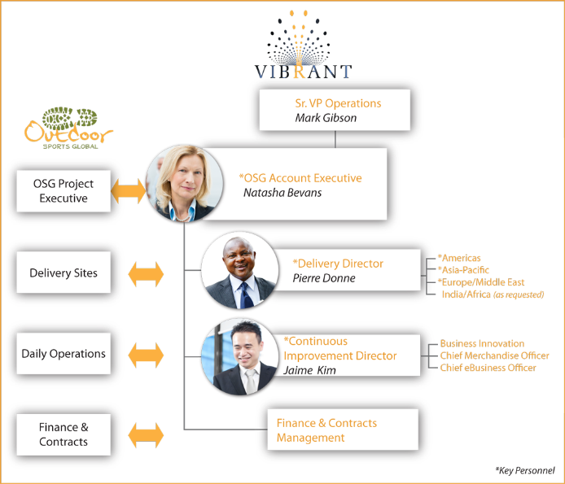

Action Caption
Figure Number | Figure Title
2.1-1 | Strong Collaboration of Vibrant Team with Multiple ESG Stakeholders

Caption
ESG will experience strong collaboration and support from the ESG project team as a result of strong dedication and clear lines of communication with ESG functional area leaders.

Creating Key Visuals
To create visual, click in space below and use these options:
- Copy and Paste from another document
- Insert Illustration (choose Picture, Clip Art, Shapes, or Chart) or Object
- Insert Table and edit with standard techniques
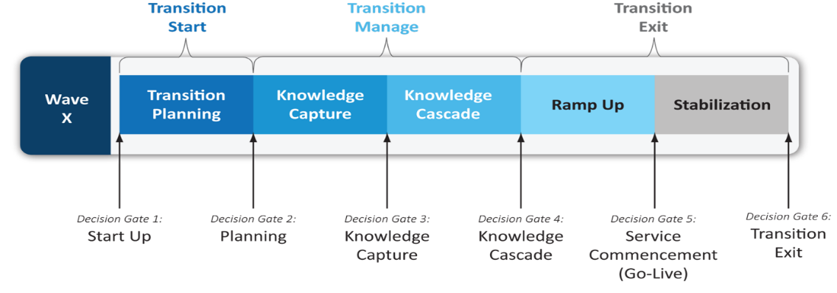

Action Caption
Figure Number | Figure Title
2.1-2 | Multiple Implementation Waves and Progressive Decision Gates for a Successful Implementation

Caption
By implementing Vibrant’s CRM system in multiple waves across various end user groups, and applying disciplined decision gates in each wave, ESG benefits from lessons learned to reduce risk and roll out early wins in successive waves.

